Microsoft Office 2013 Product Key Card Activation
Inside the product packaging you will find a card which contains the Microsoft Office 2013 product key used to activate Microsoft Office. The card looks like this:

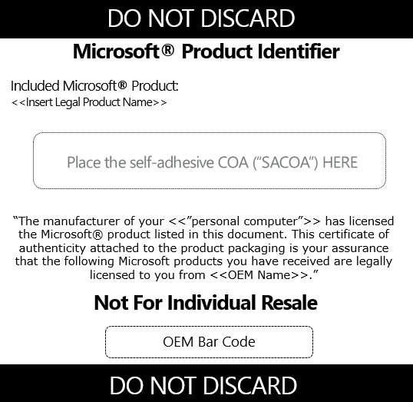

Please make sure you have this before proceeding further.

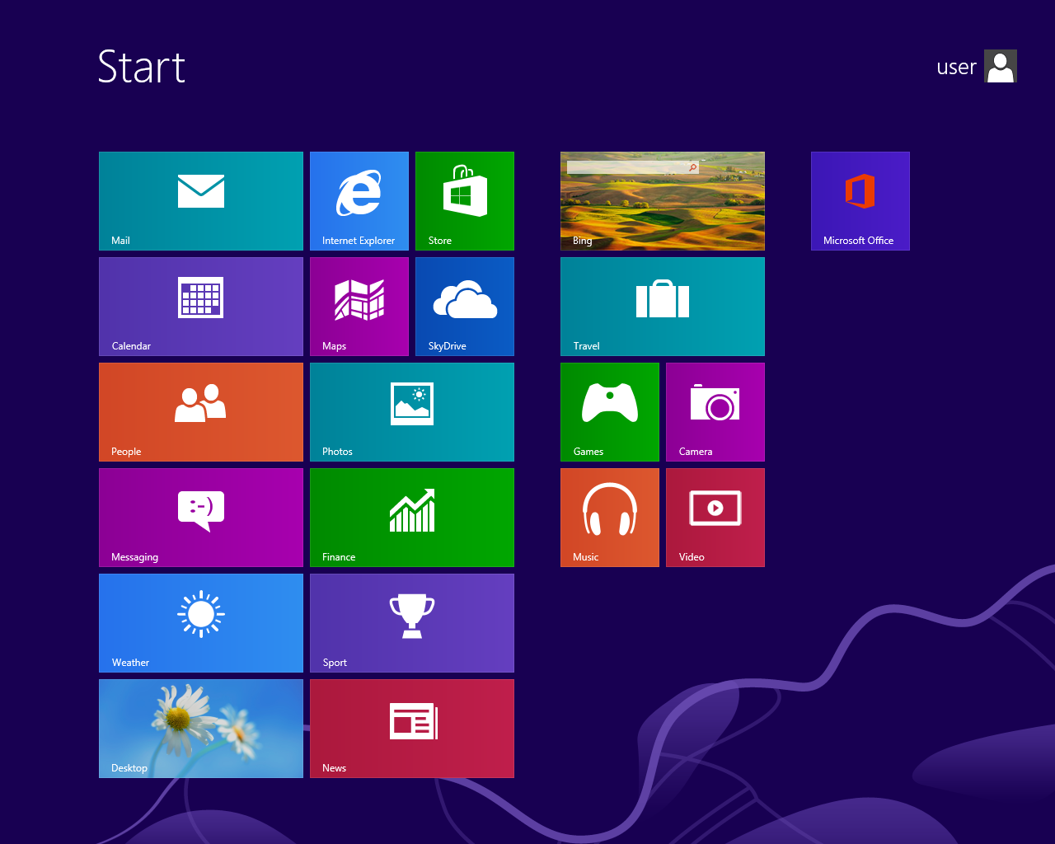
Using Windows 8 Press the Windows button or click your mouse in the bottom left corner of your screen. You will then see this:

The top right of this screen you will see the Microsoft Office logo, click this and you will be prompted by the next screen:
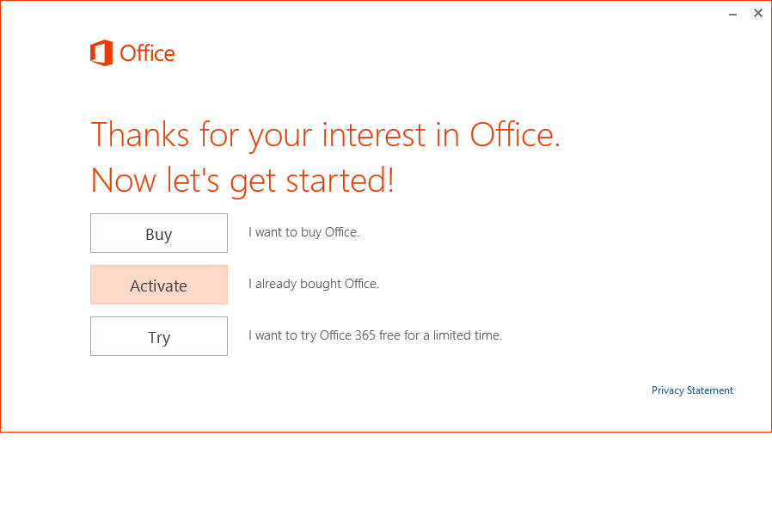

Click the”Activate” button

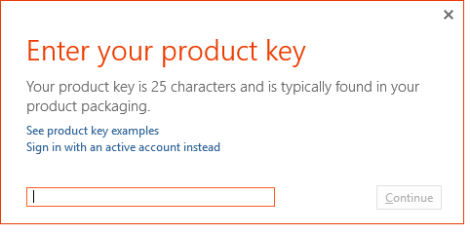
In this box enter the product key which is located on your Product Key Identifier card seen earlier.

Click “Continue” and your product will now activate. Please note you must be connected to the Internet at this step.

