iiyama Product Eco Declaration

iiyama’s sustainable mission statement.

iiyama’s full product range for many decades have conformed to industry recognised schemes to ensure we comply with the latest human safety and environmental standards. None the less as a company, we look to exceed these standards, recognising our place in the global market to work with a support a greener supply chain, utilise recycled materials and work towards establishing a true circular economy. This extends past the product level, and is an ethos we as a company strive towards. Which includes all company vehicles will be electric by 2025, business related travel will be lessened to improve overall carbon foot print, encourage the use of pubic transport or cycles, to use sustainable energy suppliers, and to work with freight forwarding companies developing greener international and local freight services.

- iiyama recognizes that its activities, products, and services may impact the environment. To minimize such impact, we commit to (i) the eradication of restricted and banned materials and substances to meet the requirements of EPEAT, (ii) to the conservation of energy associated with the development and manufacture of our products and their use and (iii) to the implementation of recycling programs through each region contracted recycler. Careful selection of raw materials and suppliers will allow us to actively promote pollution reduction by adopting Earth-friendly technologies wherever feasible.
- Establish a hazardous substance management process in accordance with the requirements of the international standard like RoHS, REACH… and control hazardous substances with the most effective process, to avoid the impact from activity, product and services to the environment, and provide products, processes and services that meet the needs of our customers.
- Promise to obey the environmental laws & regulations and to adhere and respect our customers’ environment requirements related to activity, product, and service.
- Introduce, maintain, and improve energy performance indicators and objective management plans. We have established a system as part of our ISO14001:2015 accreditation and promise to continuously improve it through regular monitoring.

As one of the world’s leading monitor brands, iiyama is willing to devote itself to the climate change issue. iiyama commits to reduce 2% of GHG emissions associated with energy use each year (based on last year level) by working closely with its suppliers.
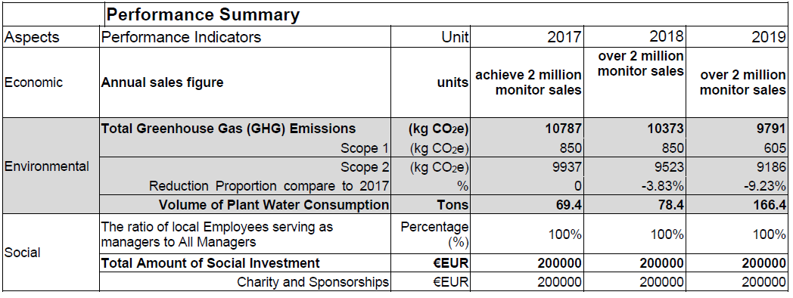
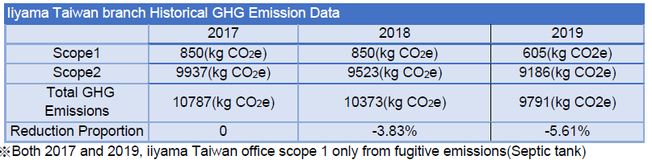
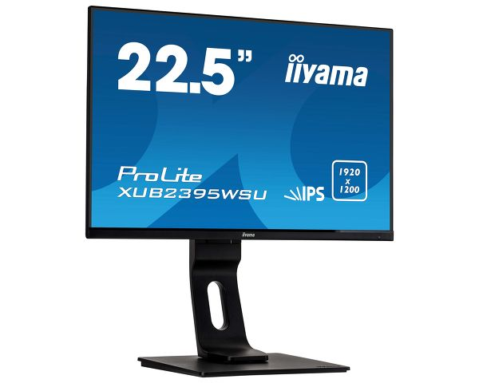
The demanding data and application heavy world needs a display that creates a more productive work place. With 1920 x 1200 resolution, the XUB2395WSU offers 11% more height with the same width as a Full HD display, which works much better for spreadsheets, word documents and browsing the Internet. The height adjustable stand with PIVOT function allows you to easily adjust the monitor position to your preferences and the IPS panel technology assures accurate and consistent colour reproduction with wide viewing angles.

PROLITE XUB2395WSU-B1
22.5” 1920 x 1200 monitor featuring IPS panel technology and a height adjustable stand
iiyama Eco Mode button allows users to toggle between 3 Eco Modes, each reducing the power consumption of the screen
The OSD Button Lock feature enables facilities management to set feature of the screen, and lock the buttons to avoid changes.

Eco Modes and Power consumption (W) | Typical | Eco Mode 1 | Eco Mode 2 | Eco mode 3 | Standby
AC 100 - 240V, 50/60Hz | 24 | 21.2 | 19.7 | 17.2 | 0.49

BTU | Typical | Eco Mode 1 | Eco Mode 2 | Eco mode 3 | Standby
BTY | 81.84 | 72.292 | 67.177 | 58.652 | 1.6709

Sustainability

Regulations | TCO, CE, TÜV-Bauart, EAC, RoHS support, ErP, WEEE, REACH
Energy efficiency class (Regulation (EU) 2017/1369) | E
REACH SVHC | above 0.1%: Lead
Statement of SVHC of REACH Regulation
We hereby declare that all our Monitors have been designed and manufactured in compliance with the restriction of use of the SVHC under REACH Regulation which is effective at the import of our Monitors into EU.
SVHC which exceeds 0.1% in our monitor is published on our website.
Each concentration of SVHC in our monitor is not designed to exceed 0.1% (excluding its substance).
This declaration is valid for all our Monitors which are currently brought in EU sales market.

All iiyama displays are RoHS compliant

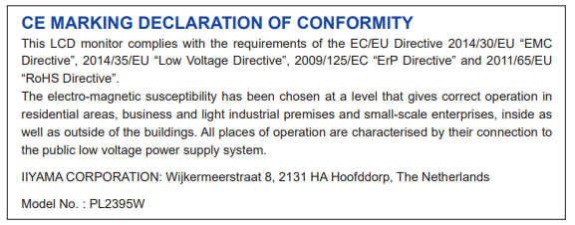

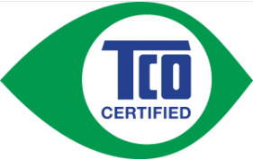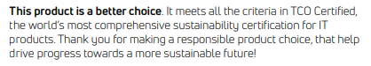

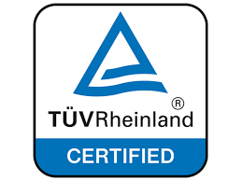
We hereby Declare that the XUB2395WSU-B1 conforms with the essential health, safety and eco-design requirements of the Low Voltage Directive 2014/35/EU , EMC Directive 2014/30/EU, ErP Directive 2009/125/EC, and RoHS Directive 2011/65/EU
WEEE Declaration - iiyama is committed to meeting it’s obligations under the regulations and is properly registered as a producer. iiyama’s producer number is WEE/FA0049TZ. This proves that we are formally registered with a legally approved Compliance Scheme. The Scheme we are registered with is called "B2B Compliance". B2B Compliance takes on the legal responsibilities of the reporting on, and the collection and treatment of, all WEEE that iiyama is obligated for - and ensures that the appropriate recycling targets are met on this WEEE.
Anyone requiring independent confirmation of iiyama’s status should ring the B2B Compliance helpline – +44 (0) 1691 676124
iiyama are dedicated to a zero landfill
Collection – iiyama will collect redundant display equipment for recycling as part of our commitment to a circular economic model, and environmental protection. All iiyama displays can be recycled by specialist partners and their materials and precious metals be recovered and used again in the future production of technology devices.
Website: http://www.b2bcompliance.org.uk

